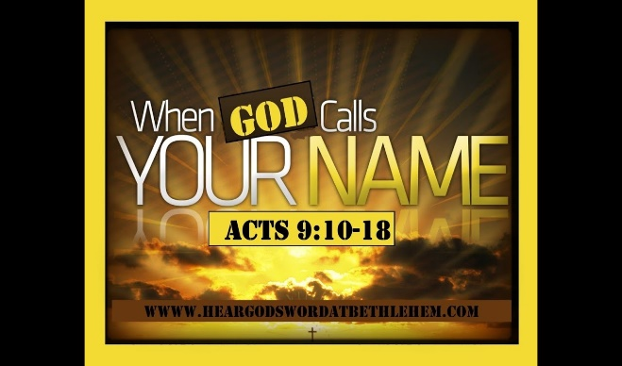
Waterkloof Baptist Church
2 June 2019 PM

INTRODUCTION
Moses had an incredible encounter with God that changed his life forever.
We ask the question “………………………………………………. ?”
Exodus 3:11-12
A personal story of God’s calling

- We all ask this question
- What motivates or limits you? - ………………………………………………
- What are your fears …?

Moses excuses
- “I’m not ……………………………………………!”
- “What’s my ……………………………………..?”
- “What if people don’t ………………………………………………?”
- “I’m not …………………………./ good ……………………………..”
- “Lord, please …………………….……………………………………..”

God’s word to me: Exodus 3:11-12

- God’s P________________ presence
- …………………………………………..
- …………………………………………..
- …………………………………………..
It’s significance --- It ………………………………… God’s people
---It …………………………………. them
2. God’s P_________________ call
- D……………………….. – God saves & calls
- D……………………….. – “I have sent you”
- D……………………….. - Moses life
3. God’s P_________________ actions
- ……………………………… (v12)
- ……………………………… (v12)

4. God’s P______________ outcome
- God’s promise
- They would be …………………………
- He would be their ……………………….. (see Exodus 6)
- People’s testimony
- “………………………………………………………..”
- Discover the Lord as …………………………

Has God called your name?
PERSONAL RESPONSE TO GOD
……………………………………………………………………………………………………………………………………………………………………………………………………………………………………………………………………………………………………………………………………….

